Type of the Presentation:
☐ Oral presentation ☐ Poster presentation

The lecturer meets the conditions of the ECIs (COST Association definition: all those engaged in research under the age of 40):
☐ Yes ☐ No

Title
First name Last name ¹, First name Last name ² and First name Last name ^{2,}*
¹ Affiliation 1 (University, Department, Street No., Zip Code city, Country)
² Affiliation 2 (University, Department, Street No., Zip Code city, Country)
* Correspondence: e-mail@e-mail.com
Abstract:
The main text, Gill Sans MT, Font size: 12, Regular. Paragraphs are justified on both left and right.
Do not change the page and margin formatting.
The limit for your abstract is ONE PAGE only. Abstracts that do not meet these formatting requirements will be returned. The organizing committee reserves the right to edit abstracts for correct formatting.
If it is beneficial for the work, the abstract can be supplemented by a picture or table as follows.
Please do not change the style of the template. If you have any questions, do not hesitate to contact us by email at raquel.alves@fmed.uc.pt
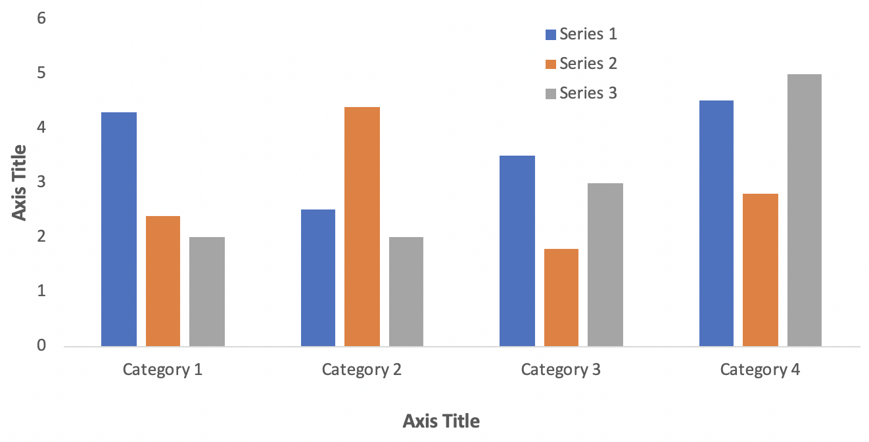

Figure 1. This is a figure. Schemes follow the same formatting. The image can be colored
Table 1. This is a table.
Title 1 | Title 2 | Title 3
entry 1 | Data | data
entry 2 | data | data ¹

Acknowledgement: not required
References: not required. We recommend using of AMA style as follows:
1. Alves R, Gonçalves AC, Rutella S, et al. Resistance to Tyrosine Kinase Inhibitors in Chronic Myeloid Leukemia-From Molecular Mechanisms to Clinical Relevance. Cancers (Basel). 2021;13(19):4820. doi:10.3390/cancers13194820

